

RAJALAKSHMI INSTITUTE OF TECHNOLOGY
(An Autonomous Institution, Affiliated to Anna University, Chennai)

DEPARTMENT OF COMPUTER SCIENCE AND ENGINEERING
(ARTIFICIAL INTELLIGENCE AND MACHINE LEARNING)
ACADEMIC YEAR 2026 - 2027
SEMESTER V

CB23531 – BUSINESS ANALYTICS LABORATORY MINI PROJECT REPORT

REGISTER NUMBER
NAME
PROJECT TITLE | Revenue Leakage Detection in Telecom Billing Using Usage-to-Bill Reconciliation and Anomaly Prioritization.
DATE OF SUBMISSION
FACULTY IN-CHARGE | Mr. N Shree Makesh

Signature of Faculty In-charge Signature of HoD

Introduction

Revenue leakage is the gap created when recorded service consumption is not translated into the amount that should have been billed. In telecom operations, a customer may generate voice, data, and messaging usage while billing logic applies an incorrect rate, discount, product rule, or incomplete usage event. This project treats the problem as a measurable data reconciliation task: estimate the expected charge from observed consumption, compare it with the billed amount, flag material mismatches, and prioritize the cases with the greatest potential financial impact.
The study uses a synthetic customer-month dataset so that the complete workflow can be reproduced without exposing private customer or billing information. The dataset deliberately includes several leakage patterns to test whether a transparent detection rule can recover known anomalies and produce business-oriented insights.

Problem Statement

Telecom billing teams may receive large volumes of usage and invoice records, making manual comparison impractical. The core analytical problem is to identify records where expected charges and billed values are inconsistent, distinguish ordinary billing variation from economically meaningful leakage, and create a repeatable priority list for investigation.

Analytical question
Can a usage-to-bill reconciliation framework identify under-billed customer-month records accurately enough to support revenue-assurance investigation and prioritization?

Aim / Goal

To develop an explainable analytics workflow that detects, quantifies, visualizes, and prioritizes potential telecom revenue leakage from usage and billing data.

Objectives

- Create a clean customer-month usage and billing dataset with reproducible assumptions.
- Calculate expected charges and leakage gaps from usage variables and plan rules.
- Detect under-billed and near-zero-billed records using transparent thresholds.
- Measure detection performance against known leakage labels embedded in the synthetic dataset.
- Visualize leakage concentration by pattern, region, month, customer record, and severity.
- Translate analytical findings into practical investigation and control recommendations.

Dataset Description

Data Source

Synthetic telecom billing dataset generated specifically for this academic project. It is not derived from real customer records and is intended to demonstrate the analytical workflow safely and reproducibly.

Data Size

1,200 customer-month records covering 12 billing months in 2025. Each row represents one customer for one billing month.

Variables / Features

Variable | Type | Description
Customer_ID | Identifier | Synthetic customer key
Billing_Month | Date | Monthly billing period
Region | Categorical | North, South, East, or West
Plan | Categorical | Prepaid, Postpaid, or Business
Voice_Minutes | Numeric | Observed voice usage
Data_GB | Numeric | Observed mobile data usage
SMS_Count | Numeric | Observed message count
Expected_Charge | Numeric | Calculated charge before leakage
Billed_Amount | Numeric | Amount actually billed in the simulation
Leakage_Gap | Numeric | Expected charge minus billed amount
Billing_Ratio | Numeric | Billed amount divided by expected charge
Leakage_Flag | Binary | Rule-based anomaly indicator
Severity | Categorical | Low, Medium, High, or Critical priority

Target Variable

The primary analytical target is Leakage_Flag, a binary indicator used to identify records that require revenue-assurance review. Known_Leakage is retained in the synthetic data only for validation and is not treated as an operationally available field.

Data Collection

The records were generated with fixed random seed 42 to make the analysis reproducible. Usage volumes were simulated from plan-specific distributions, expected charges were calculated using simple base-plus-usage rules, and controlled leakage patterns were introduced to create a known ground truth for validation. No personal, account, or payment information is used.

Data Preprocessing

Data Cleaning

Customer IDs were checked for uniqueness, billing periods were converted to dates, numeric fields were coerced to numeric types, and negative monetary values were prevented during generation. Derived fields were recalculated from the cleaned inputs rather than manually entered.

Missing Value Handling

The synthetic generation process produced complete records. A production implementation should profile missingness first and distinguish genuinely zero usage from missing usage before imputation.

Outlier Detection

Potential outliers were reviewed through billing-ratio distributions, leakage-gap magnitude, and expected-versus-billed scatter analysis. Extreme gaps were not automatically deleted because a large mismatch is itself a revenue-leakage signal.

Data Transformation

Expected_Charge, Leakage_Gap, Billing_Ratio, Anomaly_Score, and Severity were engineered from raw usage and billing fields. Billing_Ratio provides a normalized comparison across customers with different expected spending levels.

Data Encoding / Normalization

Categorical fields remain human-readable for business analysis. Numerical features are placed on comparable scales through ratio-based features rather than aggressive normalization, keeping the detection logic easy to explain.

Exploratory Data Analysis (EDA)

The first-level EDA found a mean expected charge of ₹798 and a mean billed amount of ₹696. The overall mean leakage gap was ₹101 per customer-month record. 28.6% of records crossed the review rule.

EDA measure | Value
Records | 1,200
Flagged records | 343
Flag rate | 28.6%
Total estimated leakage gap | ₹121,591
Mean leakage gap among flagged records | ₹342
Median billing ratio | 0.981

Statistical Analysis

The analysis uses descriptive statistics and association measures to understand the size and direction of the mismatch. Expected charge and billed amount are strongly aligned overall, but leakage records form the lower side of that relationship. The Pearson correlation between expected charge and billed amount was 0.842. The leakage-gap variable is therefore used as the more direct economic measure because it converts the mismatch into currency rather than only a normalized ratio.

Statistic | Value
Expected charge mean | ₹797.65
Billed amount mean | ₹696.32
Leakage gap mean | ₹101.33
Leakage gap median | ₹12.75
Expected vs billed correlation | 0.842
Rule-based precision | 99.7%
Rule-based recall | 98.0%

Data Visualization

The following figures are designed to answer different management questions: how wide is the mismatch, which leakage patterns matter most, where is the gap concentrated, whether leakage is persistent over time, which records sit far below expected billing, and how many cases fall into each priority band.
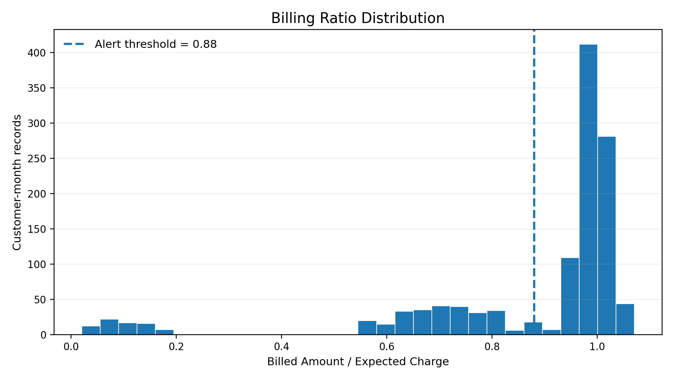
Figure 1. Billing ratio distribution with the 0.88 review threshold.
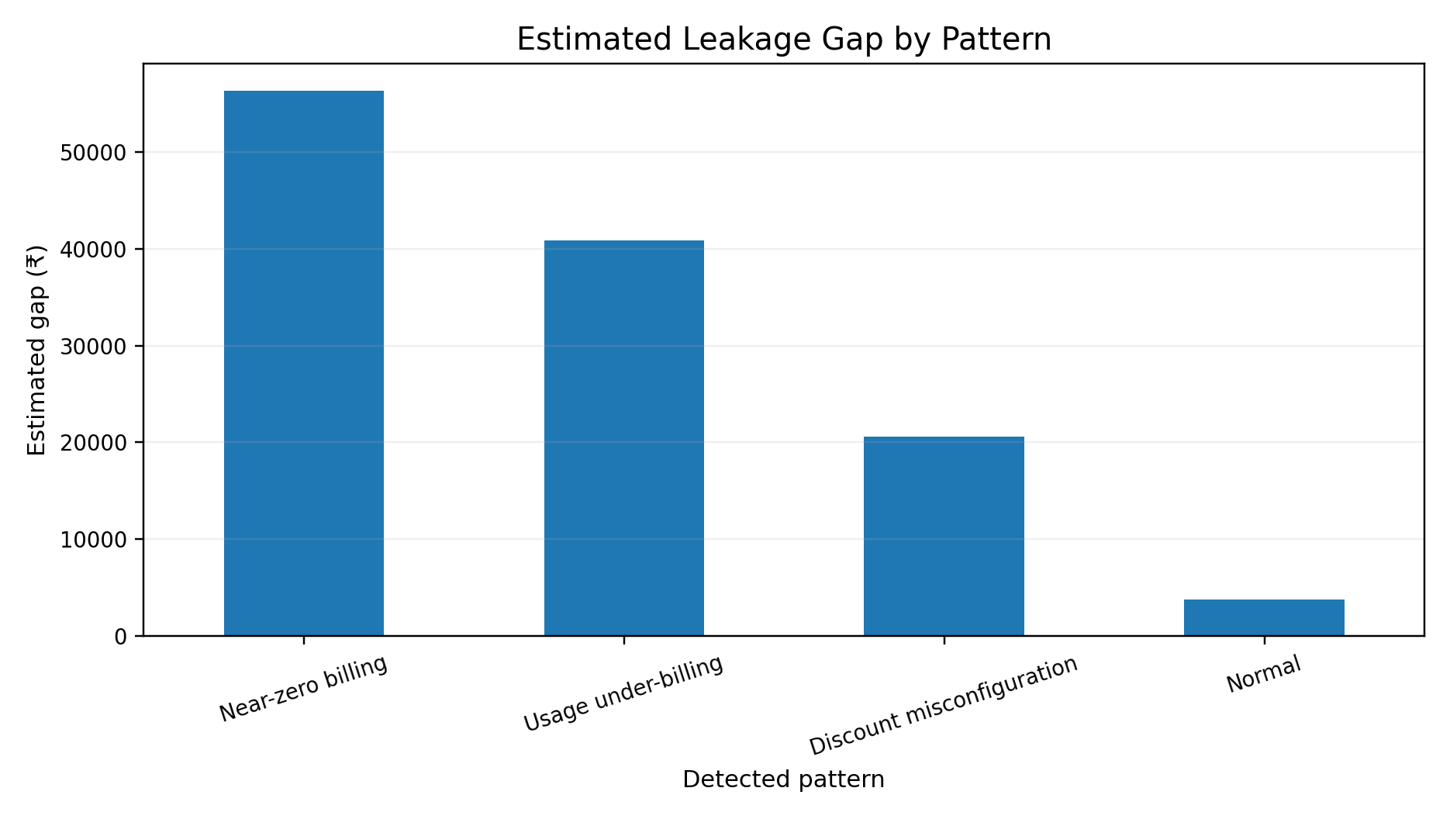
Figure 2. Estimated leakage gap by detected pattern.
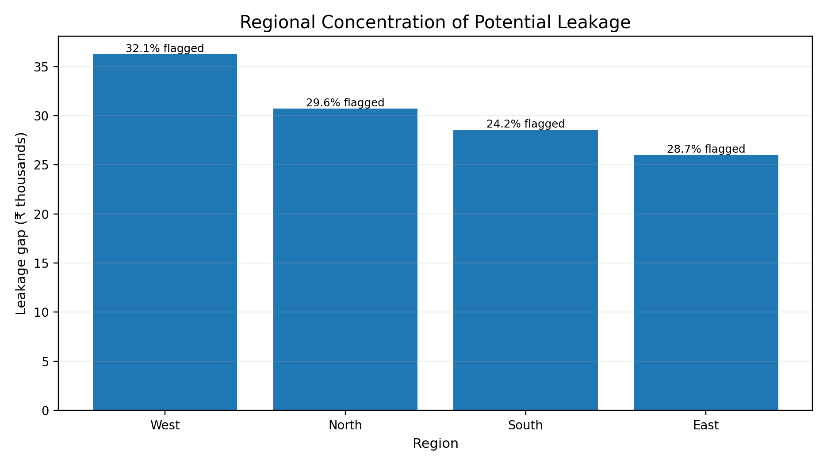
Figure 3. Regional leakage concentration with flagged-record rates.
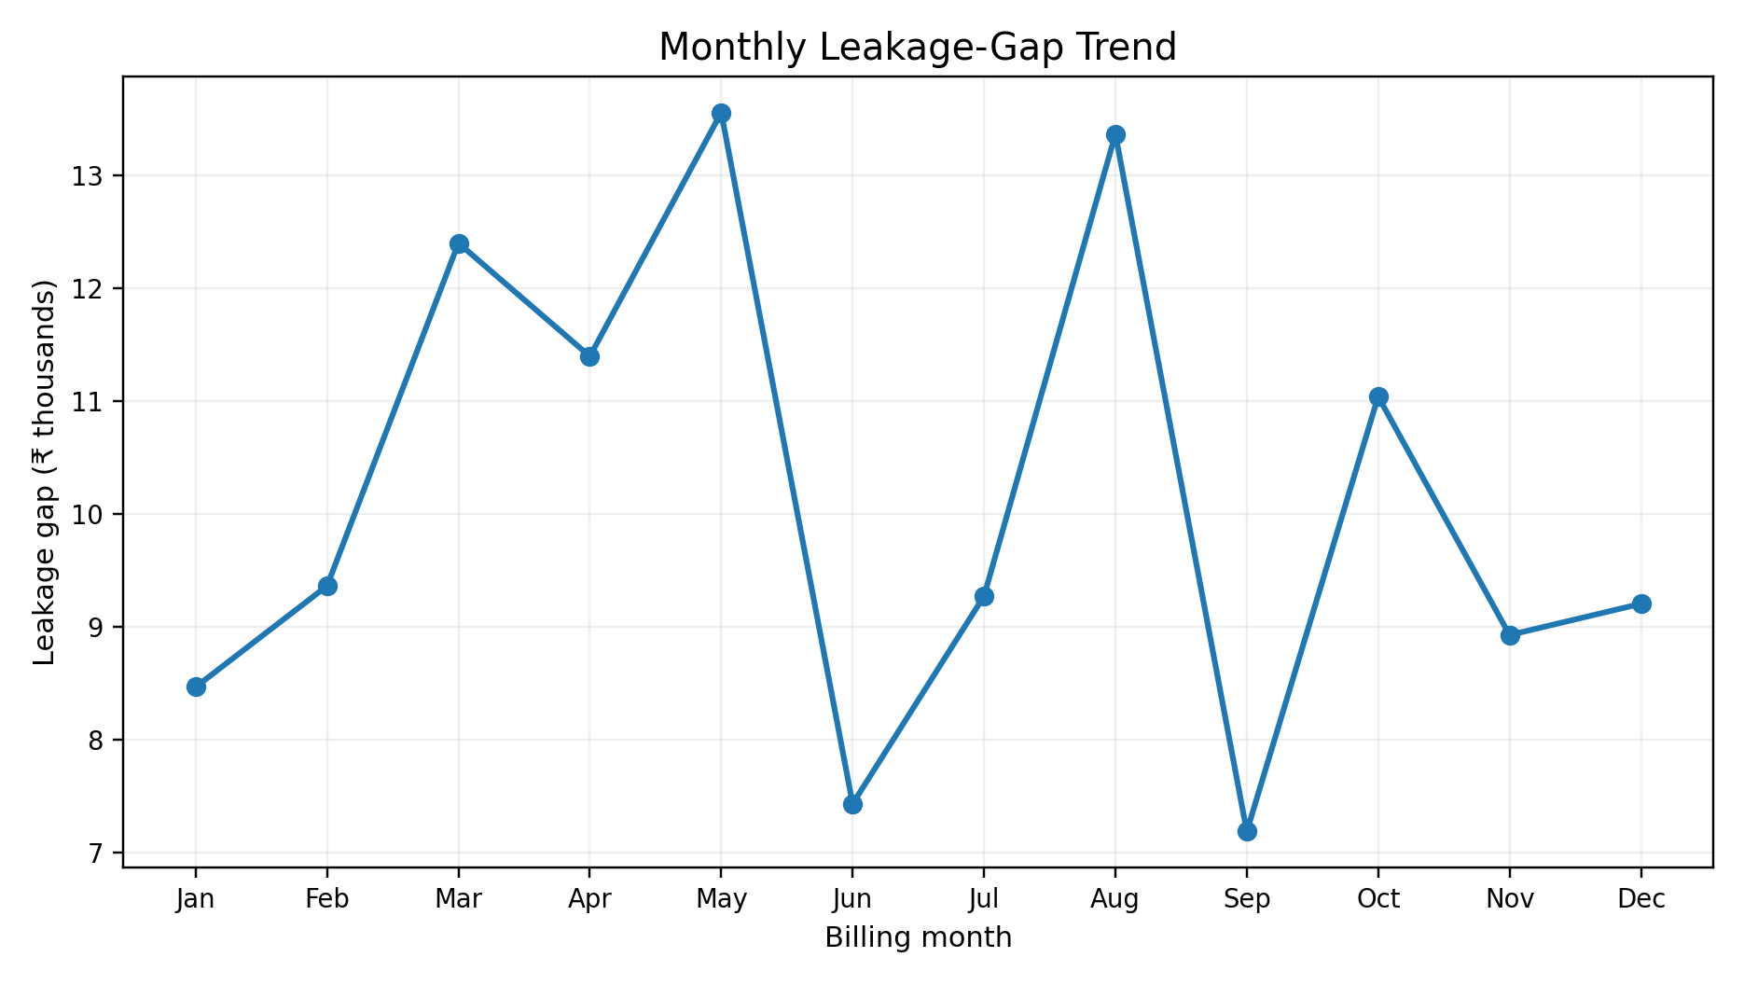
Figure 4. Monthly leakage-gap trend.
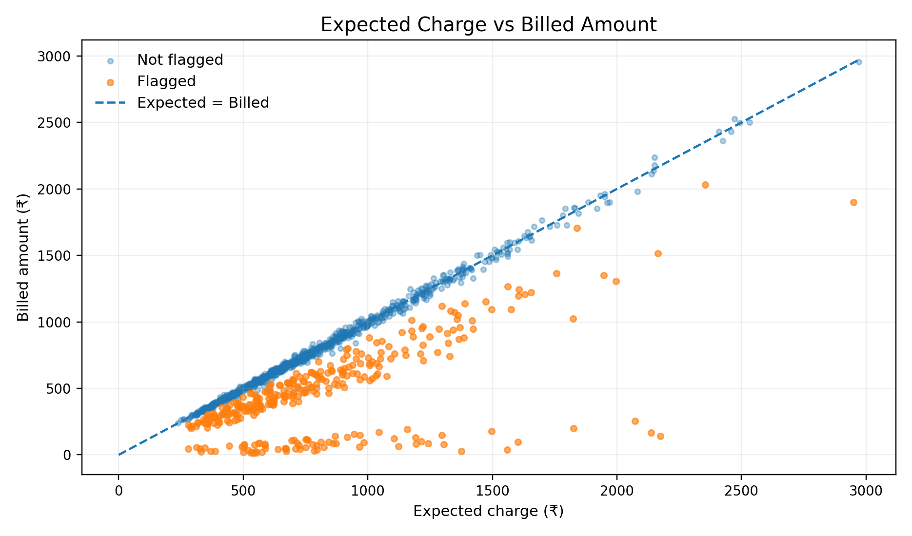
Figure 5. Expected charge versus billed amount; points below the diagonal represent under-billing.
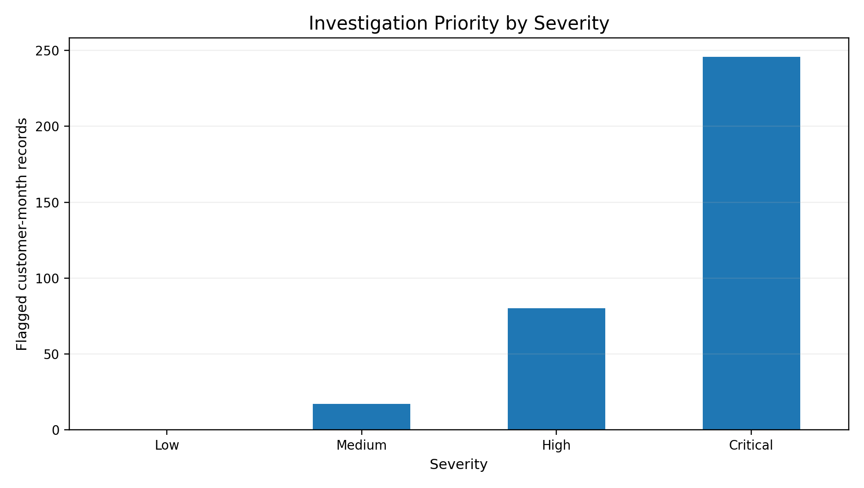
Figure 6. Investigation priority by severity among flagged records.

Business Analytics Technique / Model

Descriptive / Diagnostic / Predictive / Prescriptive Analytics

- Descriptive analytics: quantify billing ratios, leakage gaps, flag rates, and segment-level totals.
- Diagnostic analytics: compare leakage patterns across plans, regions, months, and severity groups to identify likely concentration points.
- Predictive analytics: use Anomaly_Score as a ranking mechanism for records most likely to represent material leakage.
- Prescriptive analytics: convert high-value patterns into investigation queues and control actions.

Statistical Model / Machine Learning Model / Optimization Technique

The primary model is an explainable rule-based anomaly detector: Billing_Ratio < 0.88 OR Leakage_Gap > ₹120. Anomaly_Score is then calculated from normalized billing-ratio and leakage-gap components to rank flagged cases. This choice is appropriate for an academic revenue-assurance prototype because the logic is auditable, easy to explain to finance and operations teams, and directly linked to monetary impact.

Model Development / Analysis

Expected_Charge is computed from plan base fees plus usage components. Leakage_Gap is calculated as Expected_Charge minus Billed_Amount. Billing_Ratio then normalizes that mismatch. Records below the billing-ratio threshold or above the economic-gap threshold are flagged. Severity bands are assigned so an investigation queue can be ordered by financial exposure.

Core detection rule
Leakage_Flag = 1 when Billing_Ratio < 0.88 OR Leakage_Gap > ₹120. The thresholds are illustrative control parameters and should be calibrated using historical confirmed leakage in a production environment.

Model Evaluation / Validation

Because the synthetic dataset contains a known leakage label, the rule can be evaluated directly. The detector achieved 99.7% precision, 98.0% recall, and 99.3% accuracy against Known_Leakage. These metrics demonstrate that the rule captures the injected leakage patterns with a high level of interpretability. They should not be interpreted as production performance because the validation data are simulated.

Business Insights

- The model flagged 343 of 1,200 customer-month records for review, creating a focused exception queue instead of requiring a full manual audit.
- The total estimated leakage gap in the synthetic portfolio is ₹121,591. This figure is an analytical estimate, not actual lost revenue.
- Near-zero billing contributes the largest aggregate gap at approximately ₹56,323, indicating that not all anomaly types have equal economic importance.
- The West region has the highest modeled leakage concentration, showing how geographic segmentation can guide operational investigation.
- The expected-versus-billed plot shows that severe exceptions sit far below the expected-billing diagonal, making the visualization suitable for rapid triage by analysts and managers.

Recommendations / Decision-Making

- Prioritize investigation by estimated leakage value rather than by anomaly count alone.
- Reconcile usage mediation, tariff tables, discount rules, and invoice outputs for repeated high-gap patterns.
- Create automated exception queues for near-zero billing and large under-billing cases.
- Monitor leakage-gap totals weekly or monthly and compare them with the previous billing period to identify sudden control failures.
- Close the governance loop by recording confirmed causes and recovered revenue, then use those outcomes to recalibrate thresholds.

Implementation / Dashboard

A practical dashboard can be implemented with the same engineered fields used in this study. The first screen should show total estimated leakage, flagged records, flag rate, and the top regions or patterns by gap value. A second view should provide a customer-level exception table with Customer_ID, Billing_Month, Plan, Expected_Charge, Billed_Amount, Leakage_Gap, Billing_Ratio, and Severity. A final trend view should allow operations teams to monitor whether leakage is decreasing after corrective action.
Dashboard layout: KPI cards for potential leakage; pattern ranking for root-cause focus; regional and monthly views for concentration; and an exception table for investigator drill-down.

Results and Discussion

The analytical output supports the project objective: usage-to-bill reconciliation can expose material billing mismatches and convert them into an actionable exception queue. The rule-based detector identified 343 records and captured 98.0% of the known leakage records in the synthetic validation set. The monetary view is equally important: the estimated aggregate gap is ₹121,591, while the severity and regional charts show that concentration matters more than raw case volume.
The results also demonstrate why a single KPI is not enough. A low billing ratio may indicate a configuration error, but the business consequence depends on the expected charge and the size of the gap. For this reason, the project combines normalized anomaly indicators with absolute financial exposure. The approach is intentionally transparent so that an analyst can trace every alert back to the usage, expected charge, billed amount, and rule that produced it.

Limitations

- The dataset is synthetic and therefore cannot reproduce every operational complexity of a live telecom billing ecosystem.
- The thresholds are illustrative and should be calibrated against confirmed historical leakage.
- The analysis does not model taxes, roaming, interconnect, bundles, complex promotions, reversals, credits, or multi-system reconciliation.
- The validation label is known only because the data are simulated; in production, labels would come from confirmed investigation outcomes.

Future Enhancements

- Integrate real billing, mediation, tariff, CRM, and network-usage sources with lineage controls.
- Add machine-learning ranking models such as Isolation Forest, gradient boosting, or sequence-based methods for emerging anomaly patterns.
- Introduce real-time or near-real-time detection so leakage can be identified before the next billing cycle.
- Add root-cause classification and recovered-revenue tracking to measure control effectiveness over time.
- Deploy role-based dashboards for revenue assurance, billing operations, finance, and audit teams.

Conclusion

This project demonstrates a practical and explainable approach to telecom revenue-leakage detection. By reconciling expected charges with billed amounts, transforming the mismatch into billing ratios and monetary gaps, and ranking exceptions by severity, the analysis turns a large billing dataset into a focused investigation workflow. The synthetic validation shows that the approach can recover known leakage patterns with strong interpretability, while the visual and business layers make the results easier to act on. The next step for a real organization would be calibration on historical confirmed cases and integration with billing-control processes so that detected leakage can be corrected and recovered revenue can be measured.

Tools and Technologies Used

Tool / Technology | Purpose
Python | Data generation, preprocessing, analysis, and automation
Pandas | Data manipulation and aggregation
NumPy | Numerical simulation and calculations
Matplotlib | Charts and visualization
Microsoft Word / DOCX | Report presentation and documentation

Project / GitHub Link

https://github.com/Harikrishnan-web/Sem-5-HK-Notes/tree/main/BA/Miniproject

References

Pandas Development Team. (2025). Pandas documentation. https://pandas.pydata.org/docs/
NumPy Developers. (2025). NumPy documentation. https://numpy.org/doc/
Matplotlib Development Team. (2025). Matplotlib documentation. https://matplotlib.org/stable/
Python Software Foundation. (2025). Python 3 documentation. https://docs.python.org/3/

